 | English AC V9 — Year 2
Unit 2: Examining, creating and sharing informative texts
Assessment task — Information reports☼
The K–6 Curriculum Planning Model (K–6CPM) for Australian Curriculum V9 English models a tailored approach to curriculum organisation, drawing from level descriptions, text types and integration of strands to support synchronous systematic curriculum implementation in multilevel contexts across Kindergarten to Year 6. This flexible model streamlines content and assessments through aligned contexts, allowing for adaptation of yearly contexts to sustain engagement and relevance.
Unit 2 focuses on ‘reporting information’ as a common theme. Unit contexts across successive years may explore a range of informative texts, for example:
- procedures, descriptions, explanations of a process and personal responses
- a selection of classic and contemporary informative texts
- literature of wide-ranging Australian and world authors, including that of First Nations Australians and texts from and about Asia.
The K–6CPM includes supplementary resources to support implementation in a range of schools including small schools and larger schools with complex and/or multilevel contexts.
This assessment task is aligned to the aspects of the achievement standard being assessed. Individual school contexts will inform decisions about how the task is to be implemented and how students will engage with the task.
The assessment task gathers evidence of student learning for these aspects of the Year 2 English achievement standard:
Reading and viewing
- Read, view and comprehend texts, identifying literal and inferred meaning, and how ideas are presented through characters and events.
- Describe how similar topics and information are presented through the structure of narrative and informative texts, and identify their language features and visual features.
Writing and creating
- Create written and/or multimodal texts including stories to inform, express an opinion, adapt an idea or narrate for audiences.
- Use text structures to organise and link ideas for a purpose.
- Punctuate simple and compound sentences.
- Use topic-specific vocabulary.
Speaking and listening
- Share ideas, topic knowledge and appreciation of texts when they recount, inform or express an opinion, including details from learnt topics, topics of interest or texts.
- Organise and link ideas, and use language features including topic-specific vocabulary and features of voice.
The following materials can be used when implementing Unit 2: Examining, creating and sharing informative texts in the K–6CPM English Year level plan example.
See the English Unit 2 Curriculum and assessment alignment planner (CAAP) to guide unit planning when developing a teaching and learning sequence and implementing the assessment in the unit.

Assessment conventions and resources
Purpose: To read, view and comprehend an informative text and describe the features and organisation of narrative and informative texts on similar topics. To create a written multimodal information report. To present an information report to an audience.
Technique: Observed demonstration (Part A and Part C); extended response (Part B).
Conditions
- Administer the task individually with students.
- Provide the task to students in a way that is age-appropriate.
- Length of student responses should be considered in the context of the assessment and appropriate to the year level.
- May be completed over multiple lessons.
Resources
- Example decodable text: Sheet — Informative text: Dogs (provided)
- A pet dog (pg. 1) aligns to:
- AC V9 sub-strand: Phonic and word knowledge including word structure, CV, CVC and high-frequency words, for example: ‘the’
- Literacy Hub: Phonics progression phases 1–3 (Prep).
- Fun facts (pg. 2) aligns to:
- AC V9 sub-strand: Phonic and word knowledge including word structure, CCVCC, CCCVC, CCCVCC, one- and two-syllable words and high-frequency words, for example: ‘there’, ‘their’
- Literacy Hub: Phonics progression phases 1–11 (Year 1).
- Diet (pg. 3) aligns to:
- AC V9 sub-strand: Phonic and word knowledge including word structure, multi-syllabic words and high frequency words, for example: ‘could’
- Literacy Hub: Phonics progression phases 1–17 (Year 2).
- Students are expected to read the entire text, noting that the text includes some challenging words for them to demonstrate decoding at a higher level.
- Words in the text can be adapted to align to the phonics scope and sequence used by individual schools.
- Background knowledge text: Sheet — Background knowledge text: Dogs (provided)
- Familiar authentic narrative text on a similar topic as the informative text, for example: Sterling, best dog ever by Aidan Cassie.
Implementation advice
- Adapt this assessment task to suit the diverse needs of the students, school and local context.
- When adapting the assessment, maintain alignment to the targeted achievement standard aspects and aligned curriculum elements and consider ways to make the assessment meaningful and accessible for students.
- Answer spaces have not been included to provide flexibility in how and where students will respond.
- Each part of the summative assessment may be conducted as a series of smaller tasks contributing to a collection of work to be used to gather evidence of student learning against the marking guide.
- The assessment offers tasks across varying language modes – listening, speaking, reading, viewing and writing. Teachers can adapt tasks to allow students to demonstrate the full extent of what they know, understand and can do in multiple ways. This approach ensures accessibility for varied learning needs and supports students’ unique ways of seeing, hearing and/or processing language.
Part A: Reading and viewing
Before administering the task, students engage with texts about the topic to build relevant background knowledge. Background knowledge texts can be read to students. For example: Sheet — Background knowledge text: Dogs (provided).
Select a decodable informative text that aligns with explicitly taught phonics scope and sequence program and students’ phonic development, for example: Sheet — Informative text: Dogs (provided). Students respond to questions in a teacher interview.
Instructions
- Ask students to:
- independently read aloud the decodable informative text
- monitor their own reading and, if needed, use learnt self-correction strategies
- answer literal and inferential questions about the text.
- Provide students with a familiar narrative text, for example: Sterling, best dog ever by Aidan Cassie. Students are not expected to independently decode this text.
- Guide students to answer questions about structure, language and visual features, and identify how similar topics are presented in the two different types of texts.
- Teachers may use Sheet — Teacher interview.
Note: The provided informative decodable text can be used as part of a monitoring strategy to inform judgments about students’ ability to read texts using phrasing and fluency, phonic and word knowledge and monitoring meaning. Alternatively, a text could be selected that aligns to the school’s explicitly taught scope and sequence program and students’ phonic development.
Part B: Writing and creating
Students create a short written multimodal information report on a topic from learning and/or texts. They use beginning structural features to organise and link ideas, and topic-specific vocabulary. They choose images for their text that add ideas and information.
Instructions
- Establish the audience with students and guide them to select a topic.
- Guide students to plan and talk about their factual ideas that will inform the audience about their topic.
- Ask students to write relevant facts about their topic. Prompt them to use:
- beginning text structures appropriate to an information report, including title and headings
- sequenced ideas
- adjectives that describe facts
- noun groups and verb groups to build more accurate descriptions
- topic-specific vocabulary and new vocabulary encountered in learning area texts
- other key words to represent simple concepts.
- Guide students to include images that add to or multiply the meaning of the text.
- Guide students to re-read and edit their text to make sure ideas are sequenced, add or delete words to improve meaning and identify words that might not be spelled correctly.
- Students may use the Sheet — Planning (optional) to organise their ideas.

Part C: Speaking and listening
Students present an information report to an audience. When preparing their short spoken presentation, students can use their written information report as a helpful guide. Remind them that while they may use the same information, topic-specific vocabulary and order of ideas from their written report, their presentation should not be just a reading of their text. Instead, they should engage their audience by introducing and concluding the presentation, using more formal language and using expressive features of voice.
Instructions
- Guide students to plan their presentation, and organise and link their ideas.
- Provide opportunities for students to gather supporting images such as photos, illustrations, diagrams and maps for their presentation. Students may also like to use costumes or props (optional).
- Provide time for students to practise their presentation with a partner.
- Prompt students to:
- introduce themselves and their topic (for example: ‘Good morning, my name is … My topic is …’)
- report factual information with details to elaborate
- organise key ideas in sequence
- include topic-specific vocabulary
- adjust volume, tone and pace
- conclude presentation (for example: ‘Thank you for listening to my presentation …’).
Teachers may use Sheet — Presentation: Teacher recording sheet (optional).
☼ Source: Australian Curriculum www.australiancurriculum.edu.au, CC BY 4.0. © Australian Curriculum, Assessment and Reporting Authority (ACARA) 2010 to present, unless otherwise indicated. This material was downloaded from the Australian Curriculum website (www.australiancurriculum.edu.au) (Website) (accessed 01/04/25) and was modified. The material is licensed under CC BY 4.0 (https://creativecommons.org/licenses/by/4.0). Version updates are tracked in the ‘Curriculum version history’ section on the ‘About the Australian Curriculum’ page (http://australiancurriculum.edu.au/about-the-australian-curriculum/) of the Australian Curriculum website. ACARA does not endorse any product that uses the Australian Curriculum or make any representations as to the quality of such products. Any product that uses material published on this website should not be taken to be affiliated with ACARA or have the sponsorship or approval of ACARA. It is up to each person to make their own assessment of the product, taking into account matters including, but not limited to, the version number and the degree to which the materials align with the content descriptions and achievement standards (where relevant). Where there is a claim of alignment, it is important to check that the materials align with the content descriptions and achievement standards (endorsed by all education Ministers), not the elaborations (examples provided by ACARA).
 | English AC V9 — Year 2
Unit 2: Examining, creating and sharing informative texts
Assessment task — Information reports

Name |  | Class
Teacher |  | Date
Part A: Reading and viewing
You are going to read aloud an informative text. You will then answer questions about the informative text and a narrative text on the same topic in an interview with your teacher.
Part B: Writing and creating
You are going to create a multimodal information report for an audience.
- What will your report be about?
- Who is the audience for your report?
- Plan and organise what facts and information you want your audience to learn about the topic.
- Create your report. Remember to use your planning to:
decide on your title, headings and the facts that match each heading
use the facts to write simple and compound sentences about your topic using conjunctions such as ‘and’, ‘but’ and ‘so’
sequence your ideas
include adjectives that describe the facts
include noun and verb groups
use key words, topic words and new words you have learned
write sentences with punctuation including capital letters for titles, and commas for lists
include images that add meaning, extra detail and information about your topic.
- Review and edit your work:
read your sentences to check they are in the right order and make sense
think of any words you could add, remove or change to improve the meaning
check your spelling.
Part C: Speaking and listening
You are going to present an information report to an audience.
- Plan your presentation.
- Practise presenting your report to a partner. Share ideas about what you did well and what you can improve on.
- Present your report to the audience.
Remember to:
introduce yourself and your topic
present your report with ideas in order
include facts and details
include words you have learnt about the topic
use the presentation skills you have practised (adjust volume, tone and pace)
include your images, costumes or props (optional)
conclude the presentation.
 | Marking guide — Year 2 Unit 2
AC V9 English | Name:
Assessment task — Information reports☼
Purpose: To read, view and comprehend an informative text and describe the features and organisation of narrative and informative texts on similar topics. To create a written multimodal information report. To present an information report to an audience.
 | Speaking and listening | Reading and viewing | Writing and creating
 | Share ideas, topic knowledge and appreciation of texts when they recount, inform or express an opinion, including details from learnt topics, topics of interest or texts.  Organise and link ideas, and use language features including topic-specific vocabulary and features of voice. | Read, view and comprehend texts, identifying literal and inferred meaning, and how ideas are presented through characters and events.  Describe how similar topics and information are presented through the structure of narrative and informative texts, and identify their language features and visual features. | Create written and/or multimodal texts including stories to inform, express an opinion, adapt an idea or narrate for audiences.  Use text structures to organise and link ideas for a purpose.  Punctuate simple and compound sentences.  Use topic-specific vocabulary.
Applying | Shares topic knowledge in a presentation to inform, including an introduction, conclusion and key details with elaborations from learnt topics or texts.  Organises, sequences and links ideas cohesively using language features including topic-specific vocabulary and features of voice such as adjusting tone, volume and pace for formality. | Reads, views and comprehends an informative text to provide key facts with supporting details, identifies literal meaning and integrates information from print, images and prior knowledge to make supportable inferences.  Compares how narrative and informative texts present similar topics through structure and language features to meet the purpose and identifies how images extend meaning. | Creates a written and/or multimodal information report to inform an audience about a topic, using text structures to organise and sequence related ideas, including images that add to or multiply the meaning.  Uses and punctuates simple and compound sentences, including capital letters for titles and noun and verb groups to build more accurate descriptions.  Uses topic-specific vocabulary, adjectives that describe facts and new words learnt about the topic.
Connecting | Shares topic knowledge in a presentation to inform, including an introduction, conclusion and key details from learnt topics or texts.  Organises, sequences and links ideas using language features including topic-specific vocabulary and features of voice such as varying volume. | Reads, views and comprehends an informative text to provide key facts with supporting details, and identifies literal and inferred meaning.  Compares how narrative and informative texts present similar topics through structure, language features and visual features. | Creates a written and/or multimodal information report to inform an audience about a topic, using text structures to organise and link related ideas, and including supporting images.  Uses and punctuates simple and compound sentences, including noun and verb groups to build more accurate descriptions.  Uses topic-specific vocabulary and new words learnt about the topic.
Working with | Shares topic knowledge in a presentation to inform, including details from learnt topics or texts.  Organises and links ideas and uses language features including topic-specific vocabulary and features of voice. | Reads, views and comprehends an informative text, identifying literal and inferred meaning.  Describes how similar topics and information are presented through the structure of narrative and informative texts, and identifies their language features and visual features. | Creates a written and/or multimodal information report to inform an audience about a topic.  Uses text structures to organise and link ideas for a purpose.  Punctuates simple and compound sentences.  Uses topic-specific vocabulary.
Exploring | Organises and shares topic ideas in a presentation to inform and uses language features including topic-specific vocabulary and/or features of voice. | Reads words, phrases or sentences in an informative text, and views supporting images, identifying literal meaning from the text.  Identifies the language features and/or visual features of narrative and informative texts. | Creates a written and/or multimodal text to inform an audience about a topic, using boundary punctuation in simple sentences, topic-specific vocabulary and an image.
Beginning | Shares ideas in a presentation about a topic, and uses language features, simple words and phrases and/or features of voice. | Reads sounds, words or common high-frequency words in an informative text and views supporting images, making a simple statement about the topic.  Identifies a language feature or visual feature of a narrative or informative text. | Creates a written and/or multimodal text to inform on a topic using simple sentences and an image.
Feedback:
 | Sheet

Informative text — Dogs
Dogs
A pet dog
The dog can sit.
It can run and dig.

The dog can nap and yap.
dog bed
dog

Fun facts
- There are lots of dog breeds.
- A pup is a baby dog. The mum picks it up by the scruff of the neck.
- Dogs dream in their sleep.
- Dogs are smart. They bark and howl. This is how they speak to us.
- All dogs have a strong sense of sight and smell.
- Some dogs can help us with work and keep us safe.
- Some dogs can be trained to tell when we are sick.
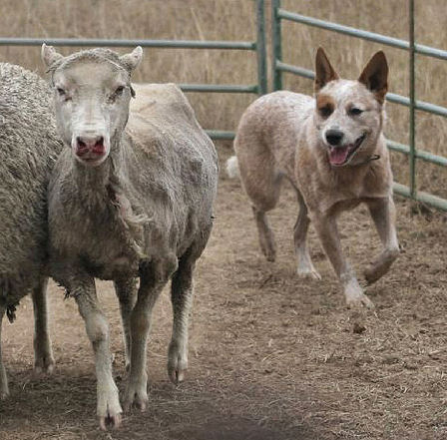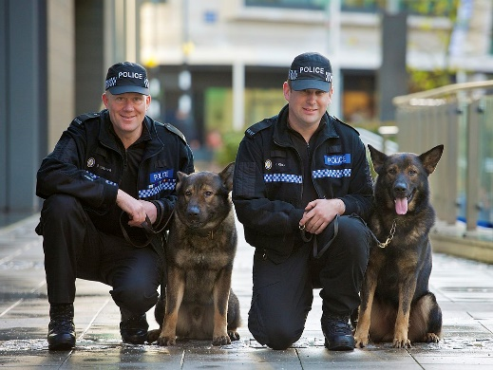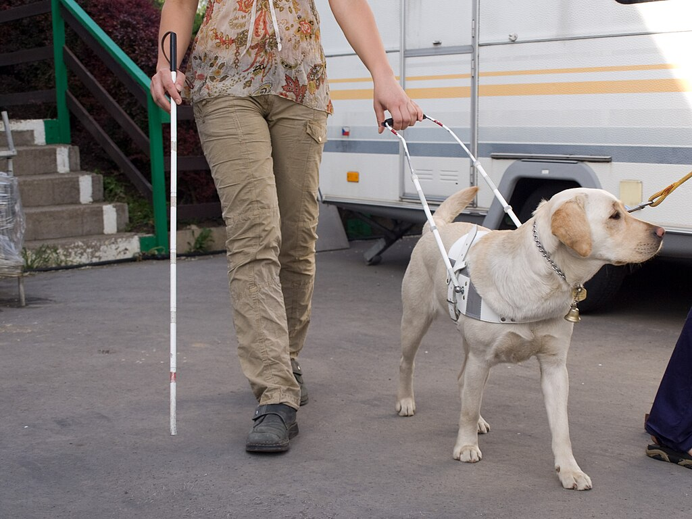

scruff
mum
eyes
nose

Diet
A dog needs a healthy diet.
A newborn puppy drinks milk from its mother.
Puppies have teeth called ‘milk teeth’ that fall out to make way for their adult teeth. They use these sharp teeth to chew meat and bones.
Dogs could get sick and need a vet if they eat foods like raisins, grapes or garlic.
A good diet and exercise keep a dog happy and healthy.
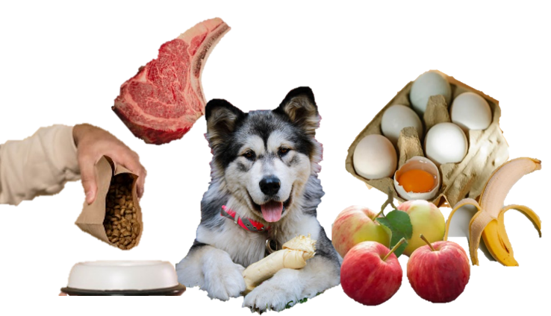 | 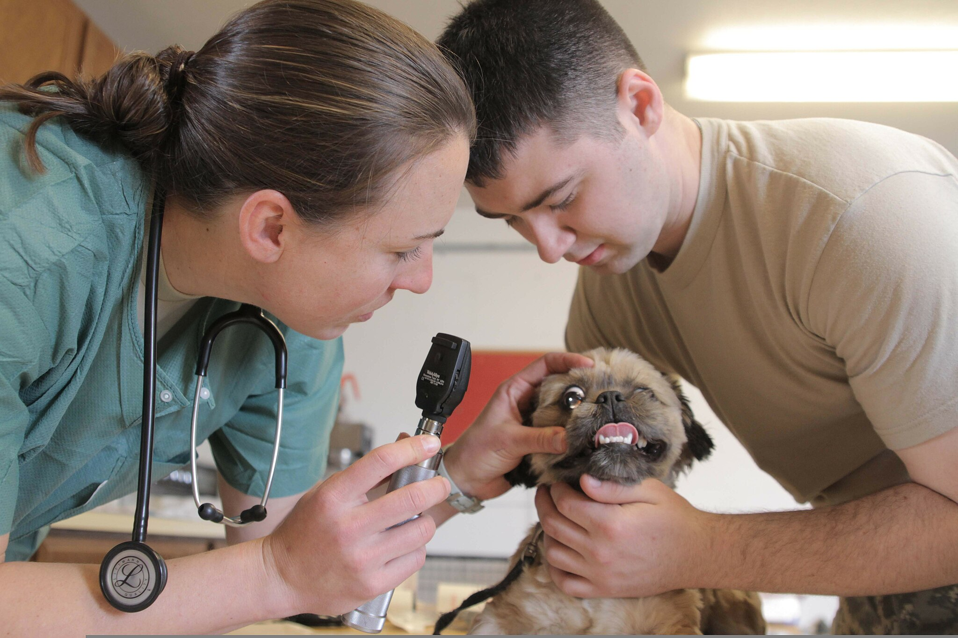

 | Sheet

Background knowledge text: Dogs
Dogs
Dogs are mammals. This means they have a skeleton, a body covered with fur and they feed their babies milk. Their babies are called puppies. Dogs belong to a group of mammals called ‘canines’, which also includes foxes, wolves and dingoes.
 |  | 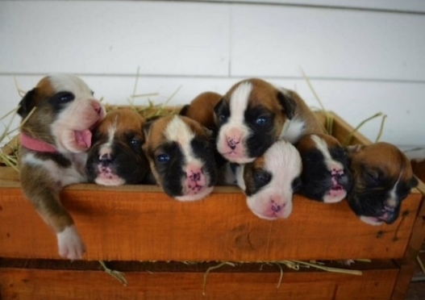

Dog breeds
There are many different breeds of dogs. Dogs can be many shapes, sizes, and colours. Some dogs are small, like chihuahuas, and some are very large, like Great Danes.

Working dogs
Dogs have excellent senses of sight, smell, and hearing. This makes them good helpers for lots of jobs. Some dogs work as police dogs, military dogs, guide dogs for blind people, or rescue dogs.
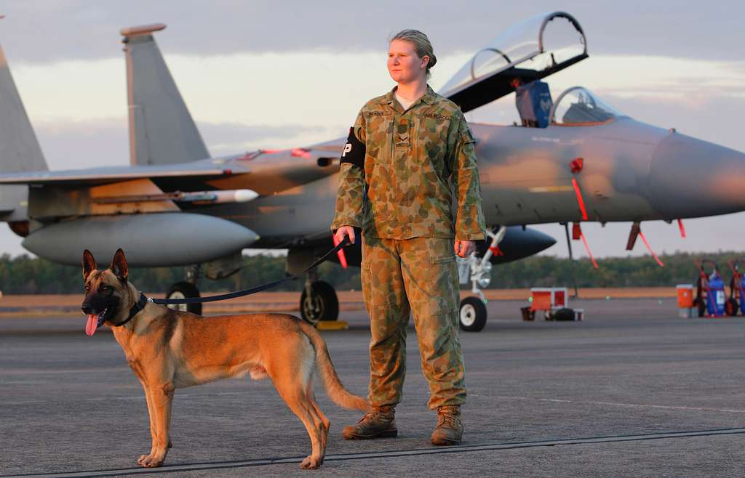 | 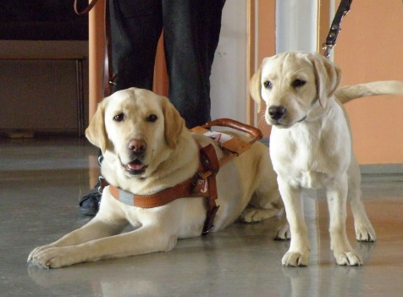 | 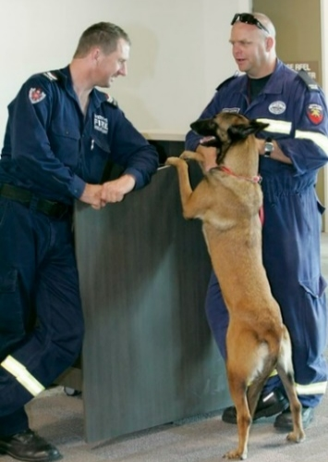
Australian Airforce dog | Guide dogs | Rescue dog and officers
Domesticated dogs
Some dogs are wild dogs and live outside but most dogs are domesticated. For thousands of years, dogs have lived and worked with people. Dogs are excellent companions, which is why they are sometimes described as ‘our best friend’. | 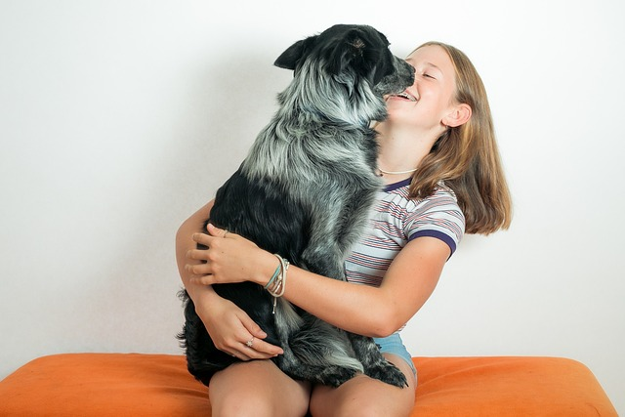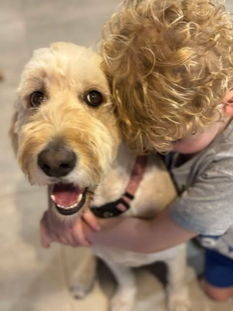
Keeping dogs healthy
Dogs need to eat a diet with lots of meat. They also can eat fruits and vegetables for extra vitamins. Not all meat, fruits, and vegetables are safe for dogs though, so owners need to be careful about their diet. Dogs should eat special pet food or other safe food. Dogs also need regular exercise like going on long walks, chasing after balls or playing with their owners.
Attributions
 | Courtesy of K Bryant. Used with permission.
 | Mdk572 2006, Australian cattle dog herding, https://commons.wikimedia.org/wiki/File:Australian_Cattle_Dog_Herding.jpg, CC BY-SA 3.0, https://creativecommons.org/licenses/by/3.0/deed.en
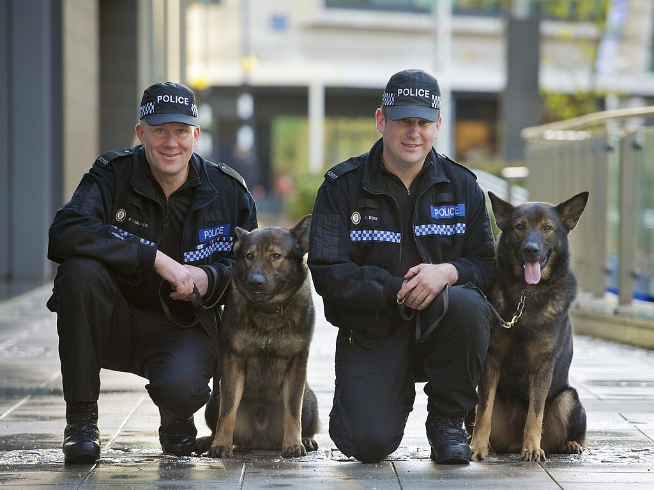 | West Midlands Police 2012, West Midlands Police - Dog handlers receive awards, https://commons.wikimedia.org/wiki/File:Day_341_-_West_Midlands_Police_-_Dog_handlers_receive_awards_%288251729393%29.jpg, CC BY-SA 2.0, https://creativecommons.org/licenses/by-sa/2.0/deed.en
 | Honza Groh 2010, SVVP Klikatá, vedení nevidomého, https://commons.wikimedia.org/wiki/File:SVVP_Klikat%C3%A1,_veden%C3%AD_nevidom%C3%A9ho.jpg, CC BY-SA 3.0, https://creativecommons.org/licenses/by-sa/3.0/deed.en
 | Courtesy of K Bryant. Used with permission.
 | Maj Guy Hayes, Army Capt. Brooke Henderson, Public Domain,  https://commons.wikimedia.org/wiki/File:U.S._Army_Capt._Brooke_Henderson,_left,_a_veterinarian  _with_the_993rd_Medical_Detachment,_U.S._Army_Reserve,_examines_a_Maltese_mix_puppy_while_  Sgt._Andrew_King,_with_the_949th_Medical_Detachment,_holds_the_dog_120418-F-ZH346-001.jpg
 | https://www.pexels.com/photo/raw-steak-in-a-tray-13279350/  https://www.pexels.com/photo/close-up-shot-of-a-dog-with-a-bone-12600137/  https://www.pexels.com/photo/set-of-raw-whole-and-broken-eggs-in-box-placed-on-table-in-sunlight-6294264/  https://www.pexels.com/photo/fresh-peeled-banana-on-white-surface-5945848/  https://www.pexels.com/photo/close-up-photography-of-apples-672101/  https://www.pexels.com/photo/a-person-pouring-dog-food-on-the-bowl-6568942/
 | Courtesy Pixabay.
 | Courtesy of K Bryant. Used with permission.
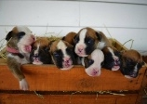 | Courtesy of A Jones. Used with permission.
 | Courtesy Pixabay.
 | Courtesy Pixabay.
 | Defense Visual Information Distribution Service 2011, Australian military working dog teams provide security at RAAF Base Darwin during Talisman Sabre 2011, Public Domain https://www.dvidshub.net/image/431082/australian-military-working-dog-teams-provide-security-raaf-base-darwin-during-talisman-sabre-2011
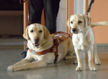 | Smerikal 2011, Guide dog looks at next generation, https://www.flickr.com/photos/smerikal/5555788581, CC BY-SA 2.0, https://creativecommons.org/licenses/by-sa/2.0/
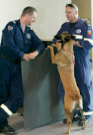 | Australian Department of Defence photostream 2011, Search and rescue dog and handler heading off to Japan, https://www.flickr.com/photos/aus_defence_force/5527462587/in/photostream/, CC BY-NC-ND 2.0, https://creativecommons.org/licenses/by-nc-nd/2.0/
 | Courtesy Pixabay.
 | Courtesy of V. Alexander. Used with permission.
 | Sheet

Teacher interview
Instructions
Review an informative text and a narrative on a similar topic. Ask students questions about the texts. Responses may be dictated to a scribe to reduce the literacy demands of the assessment. Prompts may also be provided to support students to complete the assessment, for example: ‘Tell me more’, ‘What else?’
Reading and viewing
Guiding questions | Student responses/Observations
Here is an informative text about dogs.
Tell me some key facts from the text. Use details from the text.
What foods might make a dog sick?
How can owners keep dogs healthy? Use words and images from the text and what you have learnt about in the unit.
Why don’t puppies eat bones?
What are the text structures used in an informative text?
Describe how these structures help meet the purpose of the text.
What are the language features used in an informative text?
Choose an image in the text that gives you more information about the topic.
What extra information does this image give you about the topic?
Here is a story about a dog.
What are the text structures used in the story?
Describe how these structures help meet the purpose of the text.
What are the language features used in the story?
What are some similarities between an informative text and a story?
What are some differences between an informative text and a story?

 | Sheet

Presentation
Teacher recording sheet (optional) Year 2 Unit 2
AC V9 English | Name: |  | Date:
Assessment task — Information reports

Skills |  | Comment
Introduce themselves and the report
Include facts, key details and elaborations
Organise key ideas in sequence
Use topic-specific vocabulary
Adjust volume, tone and pace
Conclude the presentation
Note: Students may demonstrate the presentation skills outlined in this checklist in a structured semi-formal presentation. Teachers may adapt this list to suit individual students and use the completed checklist to make a judgment about the skills demonstrated in this task and required further learning.

 | Sheet

Planning (optional)

